ForeSight: Empowering Vision and Security with AI-CV
N vamshi, M vaishnavi, S Ownathya, B Neha
Dept. of AI, Vidya Jyothi Institute of Technology, Aziz Nagar, Moinabad, Hyderabad, Telangana, India

Abstract:
ForeSight: Empowering Vision and Security with AI-CV is an innovative AI powered system designed to provide real-time assistance to visually impaired individuals while also supporting personnel security forces. By integrating advanced Computer Vision (CV) and Artificial Intelligence (AI) technologies, ForeSight offers dual functionality to address both accessibility and security challenges. For visually impaired individuals, ForeSight acts as a virtual assistant, enhancing their ability to navigate and interact with their surroundings independently. It uses real-time visual data interpretation to identify obstacles, read text, recognize faces, and provide auditory alerts, ensuring safety and improved situational awareness. For security forces, ForeSight offers enhanced situational awareness through precise threat detection and real-time monitoring. It identifies security breaches, recognizes suspicious activities, and delivers actionable insights, empowering personnel to respond swiftly and effectively to potential risks.
Designed with versatility and ease of use in mind, ForeSight is a powerful tool that bridges the gap between accessibility and security. It empowers individuals with visual impairments, enhances the operational efficiency of security personnel, and contributes to a safer and more inclusive society
Keywords: Visually Impaired, Obstacle Detection, AI, Computer Vision, Ultrasonic Sensors, Raspberry Pi

Introduction
In today’s digital era, visual data such as images and videos plays a pivotal role in communication, analysis, and decision-making. The integration of AI-powered Computer Vision (AI-CV) in ForeSight bridges the gap between accessibility and security challenges. The primary goals of this system are:
Accessibility: Assisting visually impaired individuals by providing auditory feedback to help them navigate their surroundings safely.
Security: Enhancing situational awareness for security personnel through advanced image processing and AI techniques.
The proposed system interprets visual data to provide auditory alerts for recognizing obstacles, identifying faces, and reading text, ensuring improved situational awareness and independent navigation. For security personnel, it delivers actionable insights such as detecting threats or intrusions.

existing system
Existing AI-powered assistive technologies, such as smart glasses for the visually impaired, integrate machine learning, computer vision, and sensor technologies. Some examples include:

Blind Assistance Using Machine Learning: Combines cameras and sensors for obstacle detection but relies heavily on predefined routes.
AI-Powered Smart Glassware for the Blind and Visually Impaired: Uses object detection and environmental navigation features but lacks real-time adaptability.
Smart Glasses for Blind People: Integrates sensors like ultrasonic and IR but faces limitations in multi-sensor integration and user comfort.
Challenges of the existing systems:

Accuracy and Reliability: Misidentification of obstacles can lead to safety concerns.
High Power Consumption: Real-time processing drains battery life rapidly.
Affordability: High costs make the systems less accessible to users.
User Comfort: The design often lacks prolonged usability, making these devices cumbersome.

proposed system
The ForeSight system integrates advanced hardware and software components to address the limitations of existing solutions.

3.1 Hardware
Raspberry Pi 4 Model B: Acts as the processing unit, running object detection models and managing sensors.

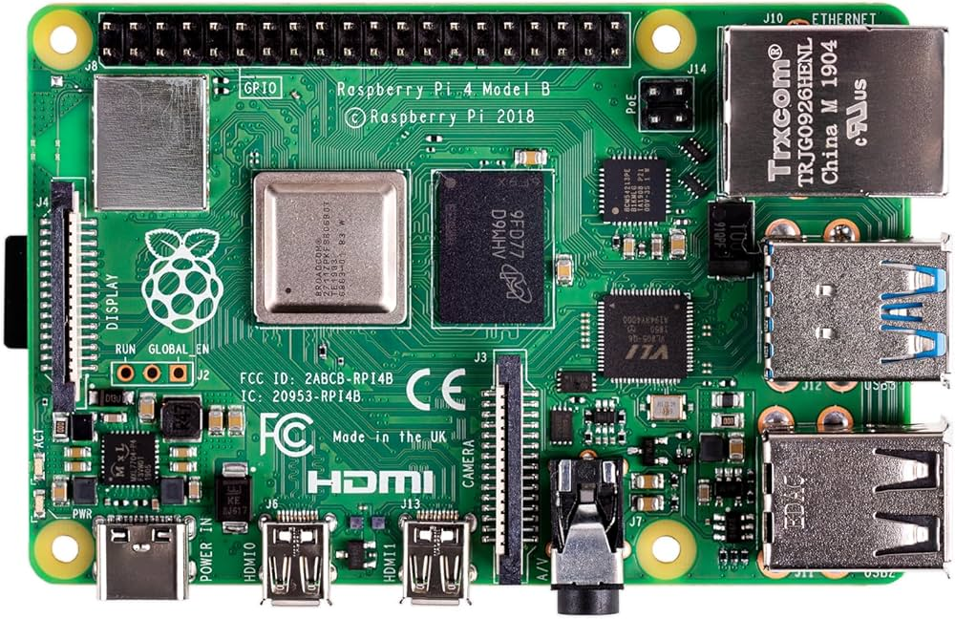

Raspberry Pi Camera Module: Captures real-time visual data for object and obstacle recognition.

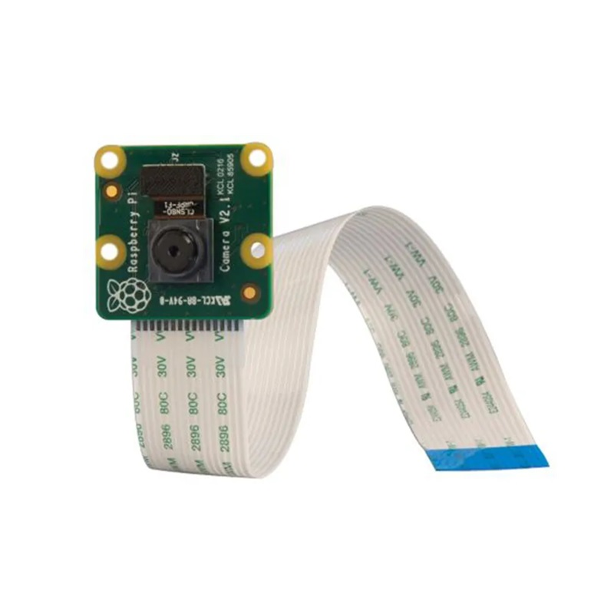

Ultrasonic Sensors: Detect obstacles and measure distances for safe navigation.

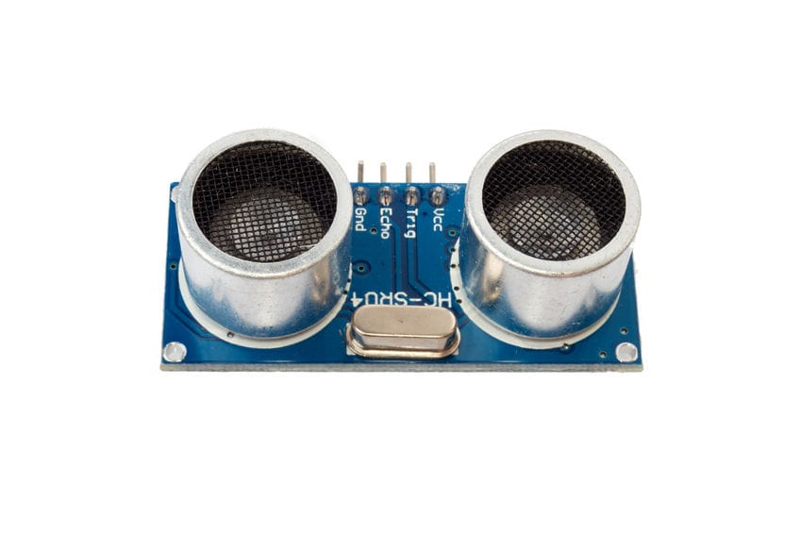

Audio Output: Provides real-time auditory feedback via pyttsx3 text-to-speech.
3.2 Software
YOLOv8 Model: Used for object detection with high accuracy and real-time performance.
pyttsx3: Provides text-to-speech audio feedback for detected objects and navigation instructions.
OpenCV: Processes the visual data captured by the camera.
3.3 Workflow
The system initializes sensors and camera, loads YOLOv8 for object detection, and sets up pyttsx3 for audio feedback.

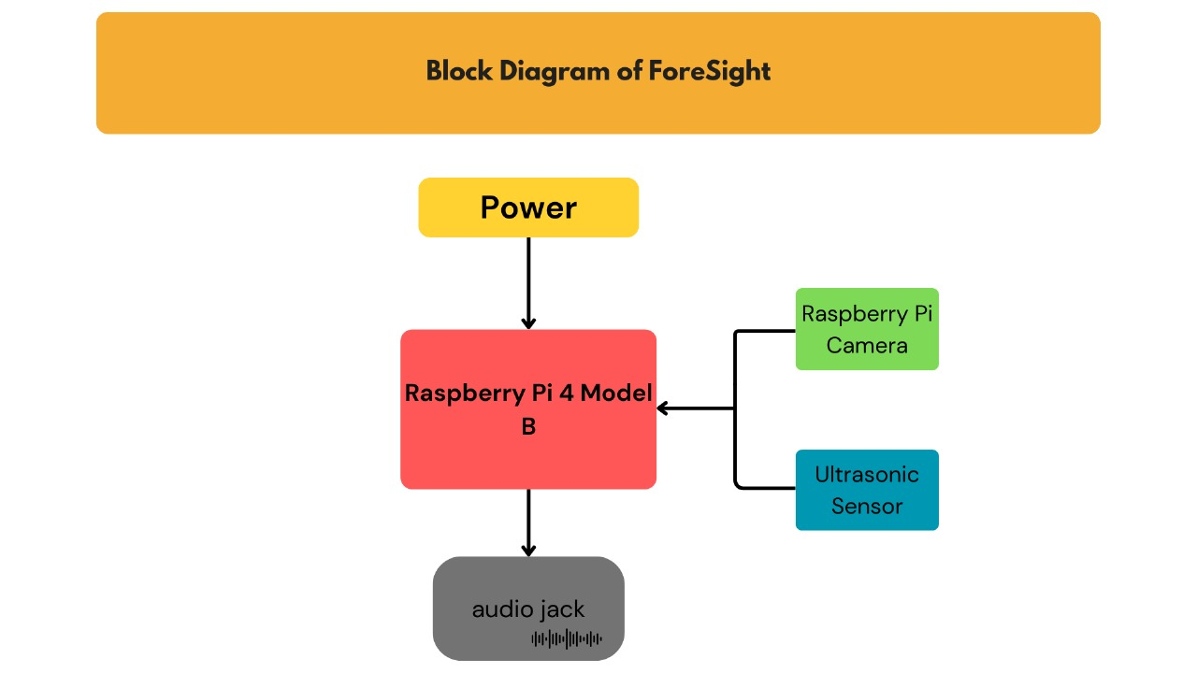

The camera captures frames, processes them through YOLOv8, and identifies objects in real-time.
Ultrasonic sensors measure distances to nearby objects.
Detected objects and distances are converted into auditory feedback to guide the user.

simulation results
The ForeSight system was tested in real-world scenarios with the following results:

Object Detection:
The YOLOv8 model successfully identified objects like chairs, people, and tables with high accuracy.

- Group of people

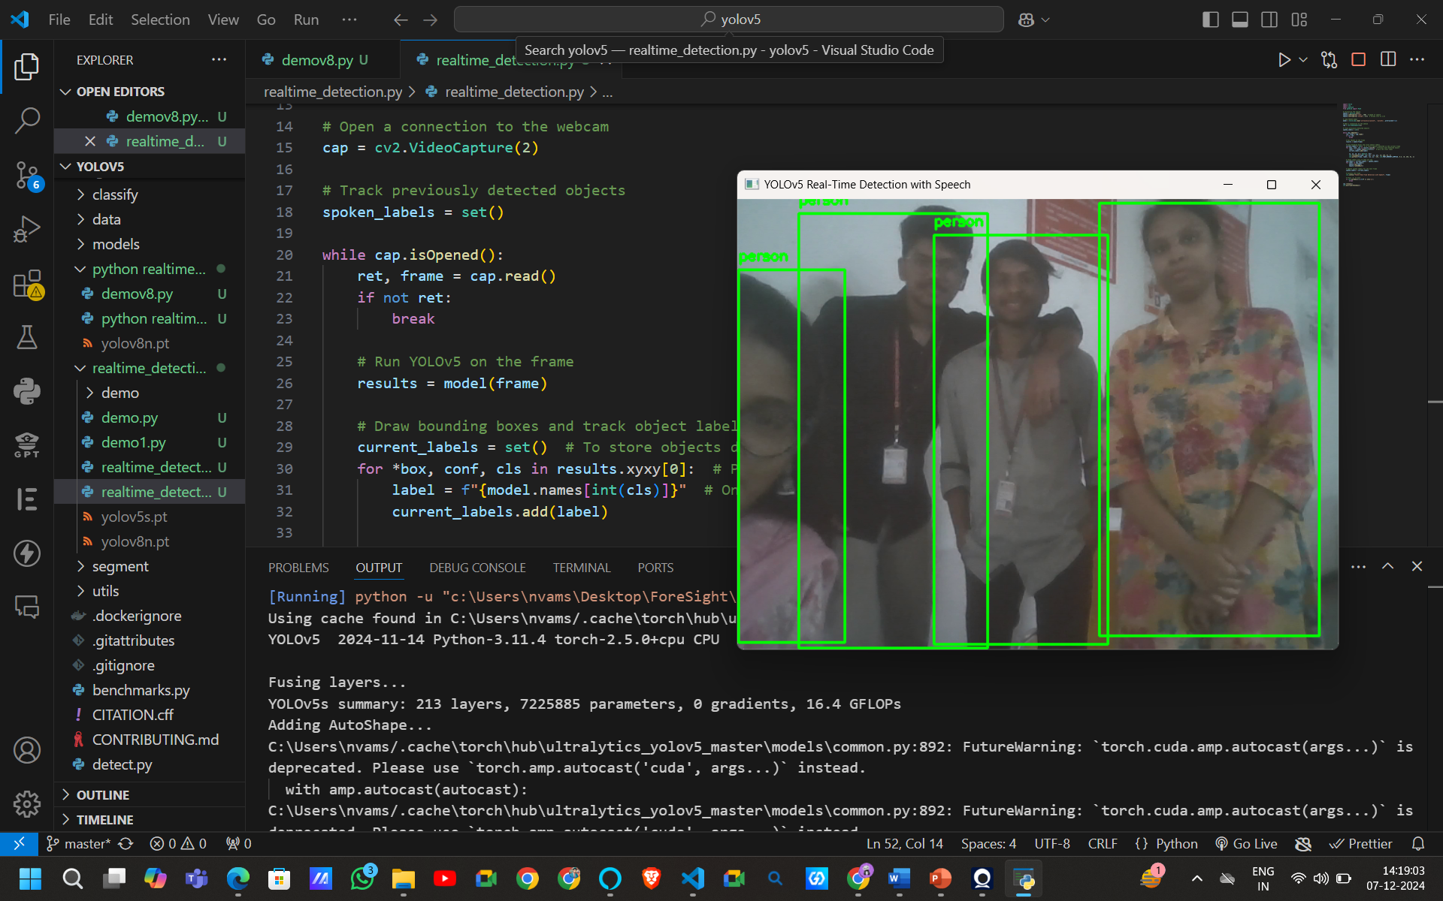

- bottle
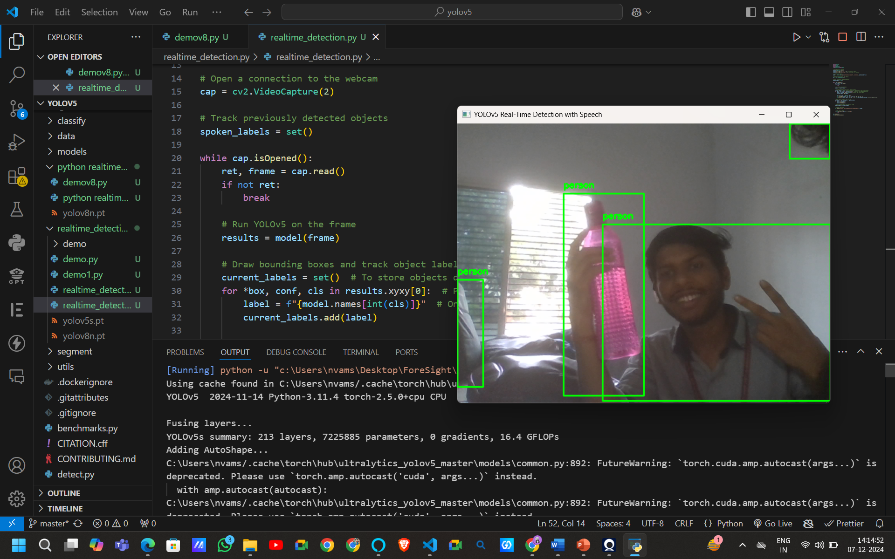

- chair
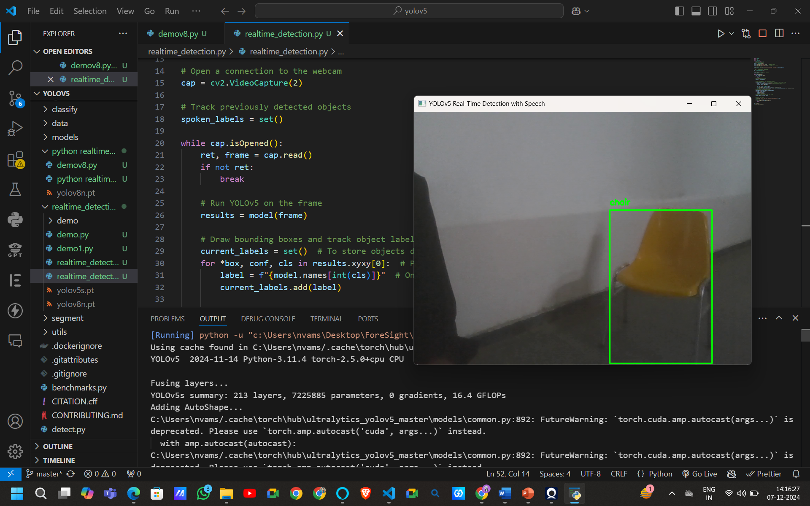
The system announced detected objects and their distances using audio feedback.
Obstacle Avoidance:
Ultrasonic sensors provided reliable proximity data, ensuring safe navigation.
Audio Feedback:
Pyttsx3 delivered intuitive navigation instructions in real time.
Challenges
Low-light environments reduced the performance of the camera, affecting object detection.
Potential improvements include integrating infrared cameras for better low-light performance and enhancing power optimization to extend battery life.

conclusion
The ForeSight project demonstrates the transformative potential of combining AI, Computer Vision, and sensor technologies into an assistive device for the visually impaired. It provides real-time navigation assistance and situational awareness by:

Detecting and identifying obstacles through YOLOv8.
Measuring distances using ultrasonic sensors.
Delivering intuitive auditory feedback using pyttsx3.
While challenges such as low-light limitations persist, the system has proven effective in increasing the safety, independence, and mobility of visually impaired users. Future iterations aim to improve low-light performance, reduce power consumption, and enhance the affordability and usability of the system.

references

1.Blind Assistance Using Machine Learning by Rajesh K S, Abhishek, Akarsh, Gagan, Mahesh, and Sachin.

2.AI-Powered Smart Glassware for the Blind and Visually Impaired by Sowmiya, Deepika, Elanthendral, Grithika, and Jeevitha.

3.Smart Glasses for Blind People by Anusha, Charan, Yamini, Manisha, and Pavan.

4.Implications of Computer Vision Driven Assistive Technologies Towards Individuals with Visual Impairment by Linda Wang and Alexander Wong.

5.Clearway Companion - An AI Powered Aid for Visually Impaired by Akshay Panchal, Chinmayi Naik, Devang Mahimkar, Ajay Chougule, and Megha Gupta.

